How to install oscommerce 2.3.3.4 with Bootstrap 3

- Go to this web page and download a copy of the version you want:
http://forums.oscommerce.com/topic/404711-234-gold-edge-24/

As mentioned in the first post by burt, there are two versions currently available.

Download the GOLD release.
This release is a v2.3.4[r] snapshot that works, and is stable. If you are not of a technical mind and you do not want to spend time on one by one updates when new code is released, you should choose this version. At some point, you will update to the next released version (v2.3.5[r]) and this will be easy if you have not changed any core code in the build.

OR
Download the EDGE release.
This is the latest v2.3.4[r] codebase, with up to the minute you download bugfixes and code changes. You should choose this version if you are of a technical mind and are able to copy/paste the changes made as they are made. If you keep on top of updates, you will always have the latest code base and never need to upgrade.

- Copy these zip files to the relevant folder on your web server and extract them.
Point your web browser to this location.
For these examples they have been installed locally with addresses of
http://gold.oscommerce.com for the GOLD version
and
http://edge.osommerce.com for the edge version.

GOLD install
Navigate to the folder on your webserver when you extracted the files.
You should see this screen if everything is OK.

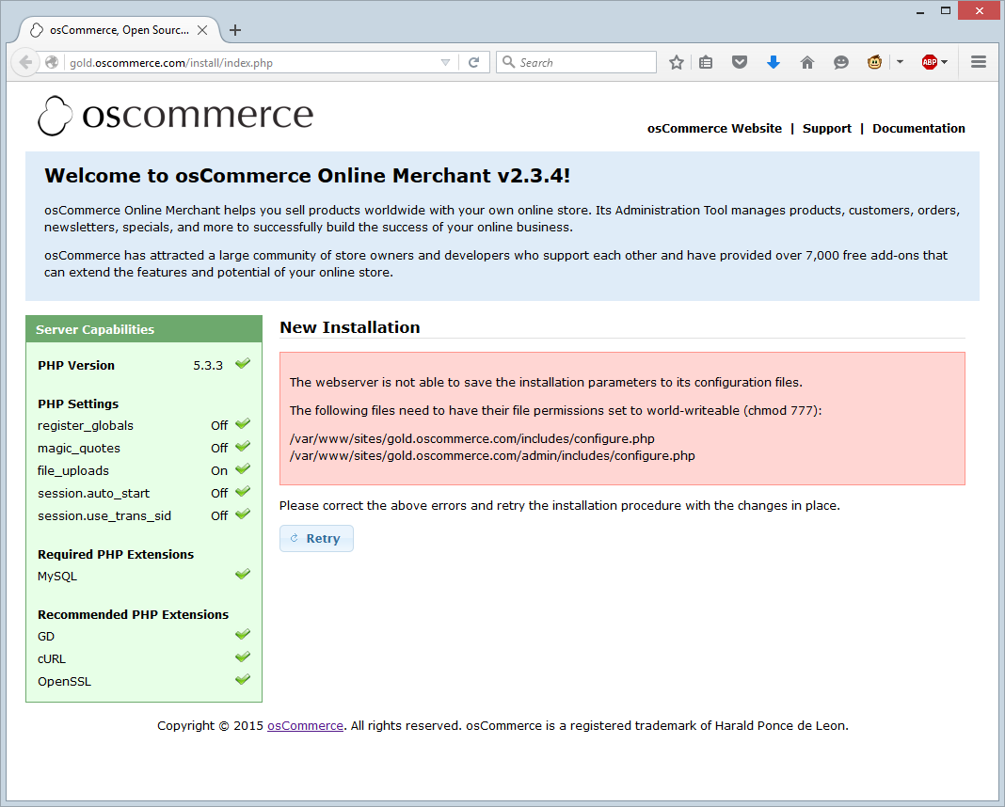

By default the two configuration files are not writable by the web server.
Using either your FTP application or the command line change the permissions on these files to 777.
This is just a temporary measure so the install can update these files with the correct information.

When you have successfully done that, press the “Retry” button and you should see this screen:
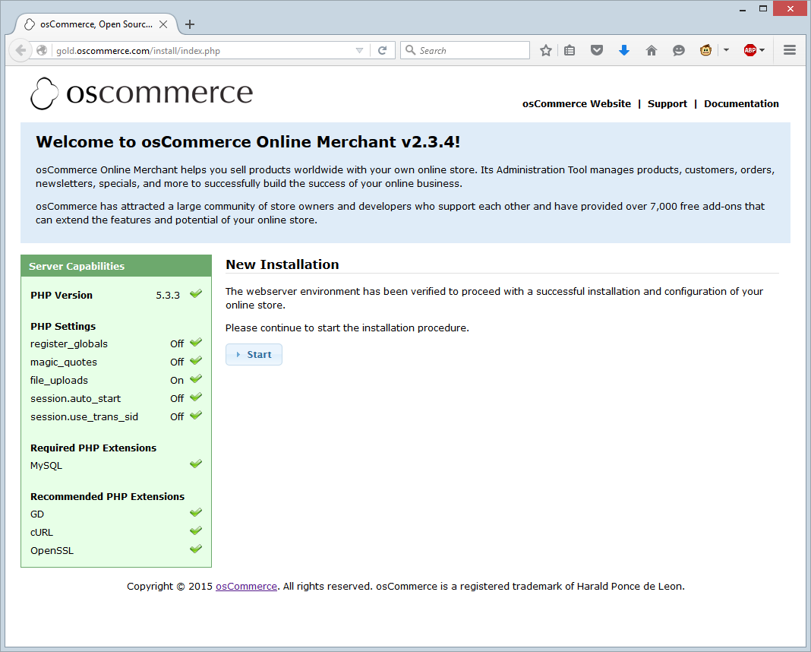
Press “Start”.
The next step is to provide the information about the database server as well as the username, password and name of the database to be used.
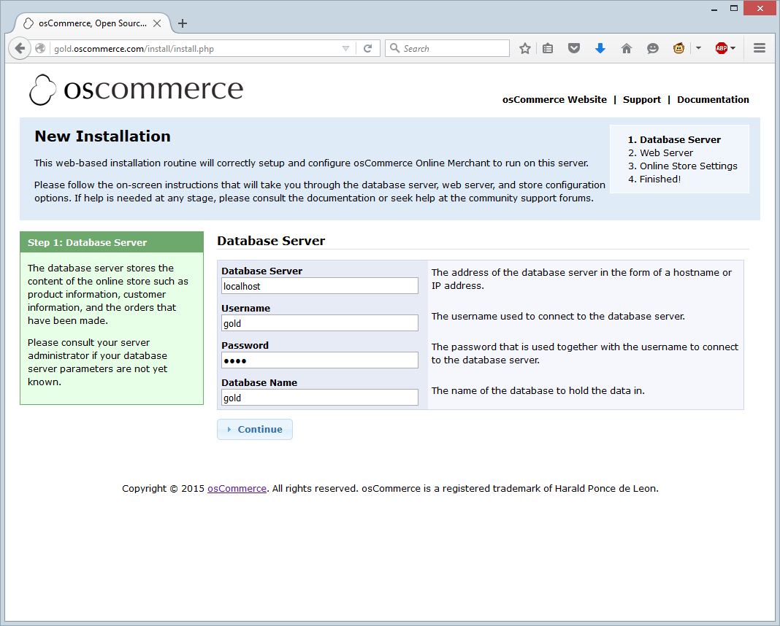
When you have filled in the boxes, press “Continue”. If all is good, you should see this screen next:
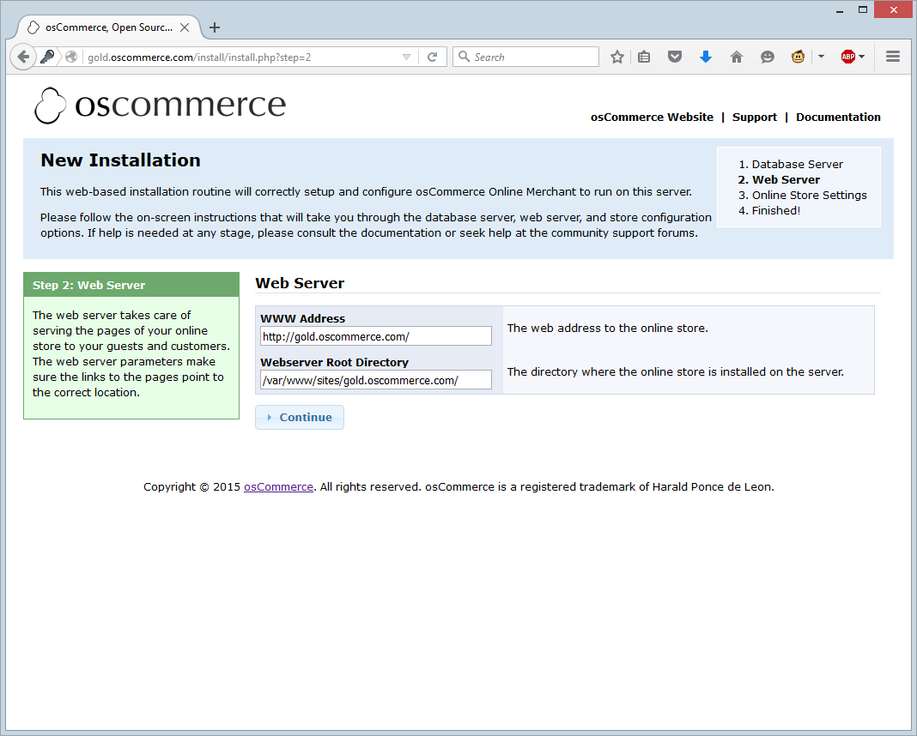
If you need to, change the information here and press “Continue”.
This brings up a screen asking for basic information about the store. All this can be changed later so don’t worry if you get something wrong.
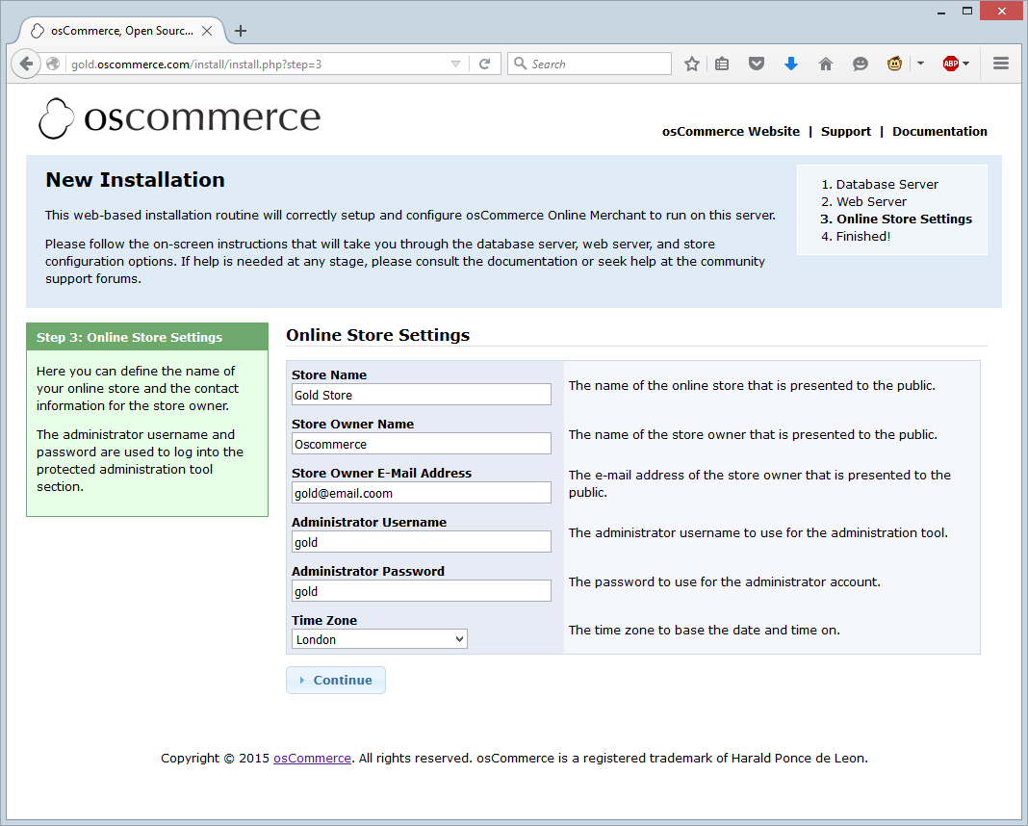
You are mostly done now. There are a few more steps to complete before you have a working store.
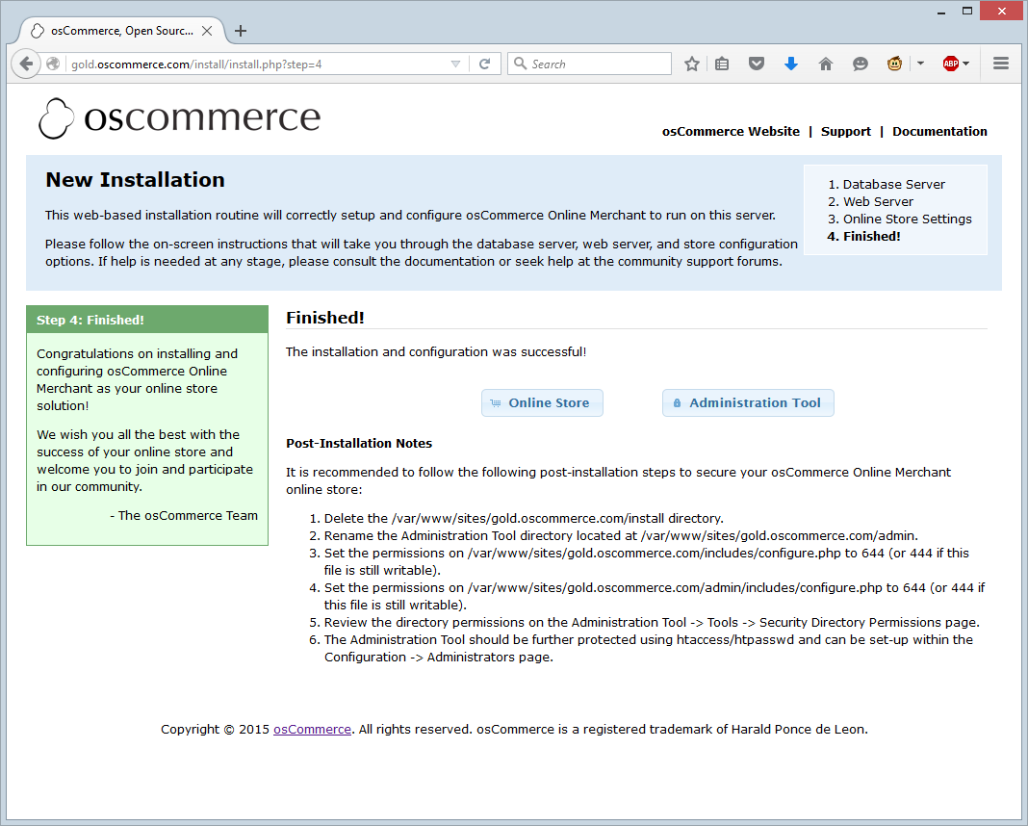

Further steps, as mentioned on this screen:
- Delete the /var/www/sites/gold.oscommerce.com/install directory.

- Rename the Administration Tool directory located at /var/www/sites/gold.oscommerce.com/admin.

- Set the permissions on /var/www/sites/gold.oscommerce.com/includes/configure.php to 644 (or 444 if this file is still writable).

- Set the permissions on /var/www/sites/gold.oscommerce.com/admin/includes/configure.php to 644 (or 444 if this file is still writable).
- Review the directory permissions on the Administration Tool -> Tools -> Security Directory Permissions page.
- The Administration Tool should be further protected using htaccess/htpasswd and can be set-up within the Configuration -> Administrators page.

These steps are mostly self-explanatory.
Step 1 is telling you to delete the install folder so this install wizard can’t be run again.
Steps 3 and 4 are ensuring that the configuration files are changed to read only so they can’t be hacked.
Steps 5 and 6 are easy enough to do once you are logged in.
Step 2 is a little more involved.
“Rename the Admin directory located at “/var/www/sites/gold.oscommerce.com/admin”
- Change the name of the admin directory using either the command line, or FTP. For this example it has been renamed to “gold_admin”. Please don’t use this for your install though.
- Edit the “/var/www/sites/gold.oscommerce.com/admin/includes/configure.php” file to reflect this change.
  - Line 7 change
define('HTTP_COOKIE_PATH', '/admin');
to
define('HTTP_COOKIE_PATH', '/gold_admin');
  - Line 8 change
define('HTTPS_COOKIE_PATH', '/admin');
to
define('HTTPS_COOKIE_PATH', '/gold_admin');
  - Line 13 change
define('DIR_WS_ADMIN', '/admin/');
to
define('DIR_WS_ADMIN', '/gold_admin/');
  - Line 14 change
define('DIR_WS_HTTPS_ADMIN', '/admin/');
to
define('DIR_WS_HTTPS_ADMIN', '/gold_admin/');
  - Line 15 change
define('DIR_FS_ADMIN', '/var/www/sites/gold.oscommerce.com/admin/');
to
define('DIR_FS_ADMIN', '/var/www/sites/gold.oscommerce.com/gold_admin/');

Save the file and then go to your new admin folder and log in.
For this example, http://gold.oscommerce.com/gold_admin/
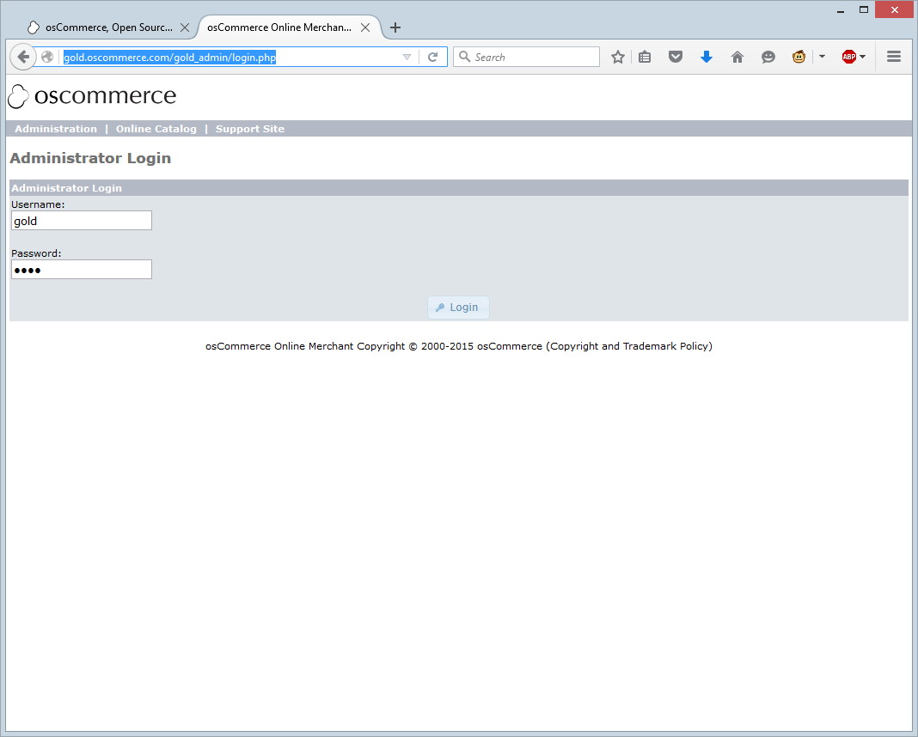

Extra steps required.

When you first go to your store’s front page, you may notice that there is no header or footer visible
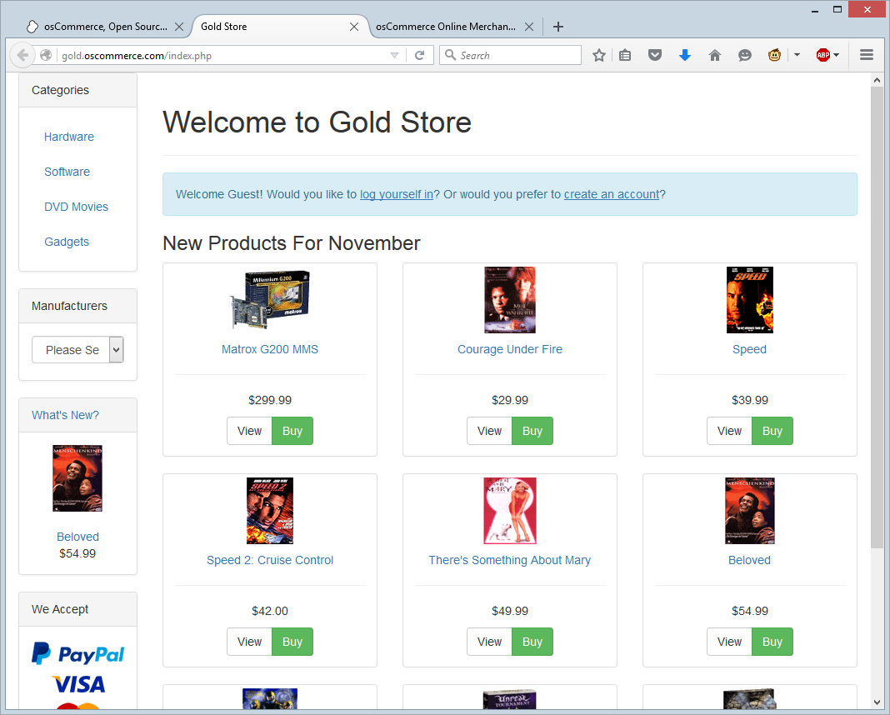
This is due to the bootstrap / responsive layout.
To get them showing follow these steps:
- Login to the admin section of your store
- In the left hand menu, open up the “Modules” box.
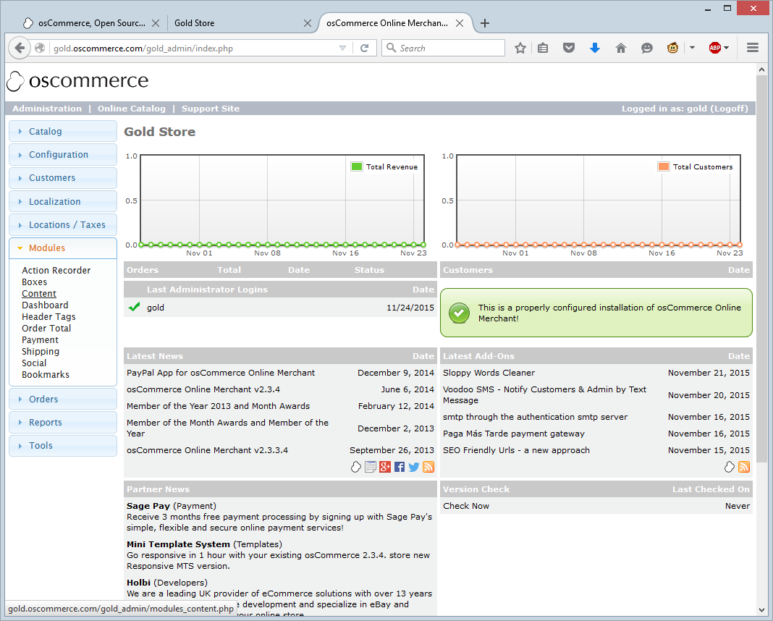

Click content, and then on the top right, click “ + Install Module”
- You should now see a selection of extra modules that can be loaded, such as logo, breadcrumb, and so on. Select the ones you want and click “Install Module”
This screen grab shows a default store with “Breadcrumb”, “Logo”, “Search Box” and “Navigation” switch on.

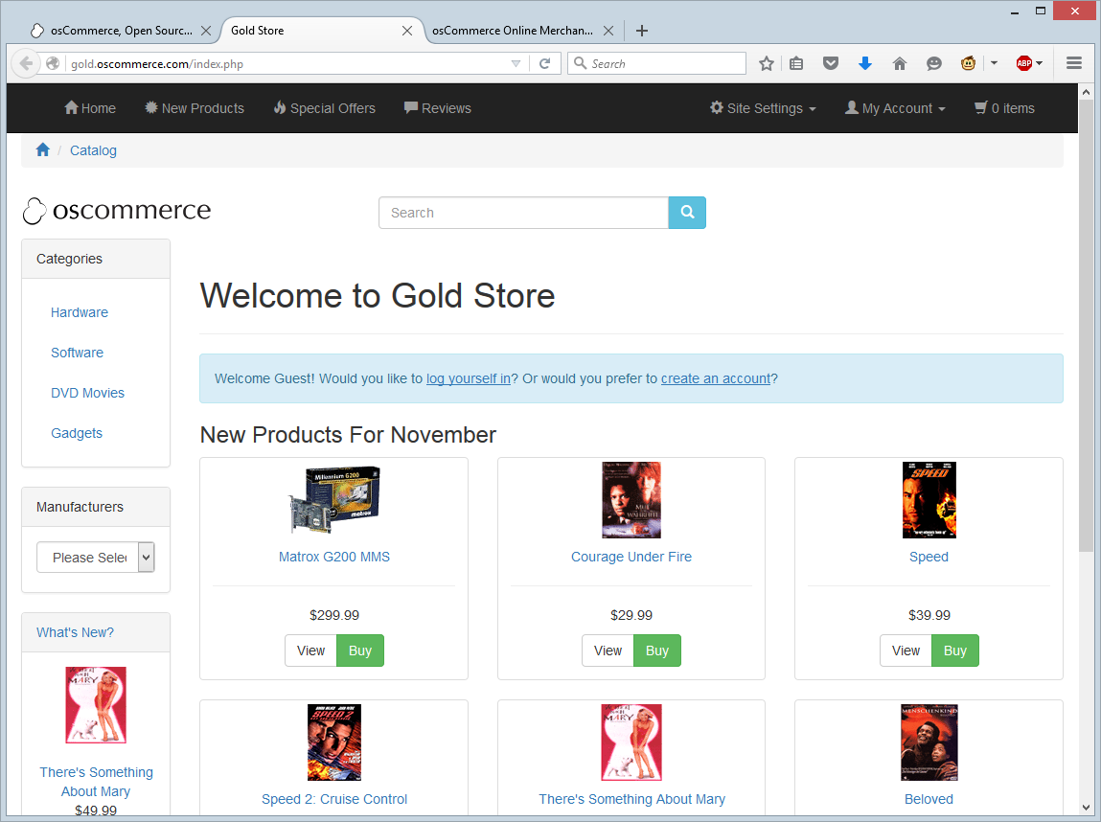

The same is true for the footer.
By default it looks like this:
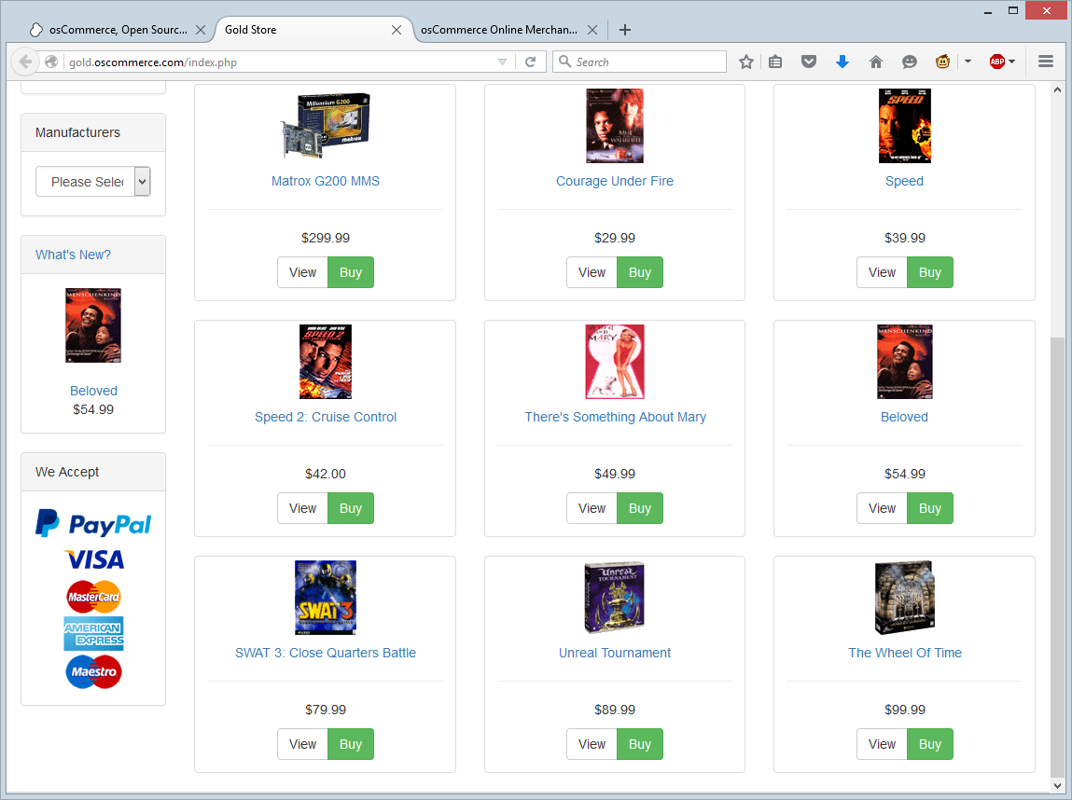
But with “Account block”, “Contact Us Details” and “Copyright Details” on, it looks like this.
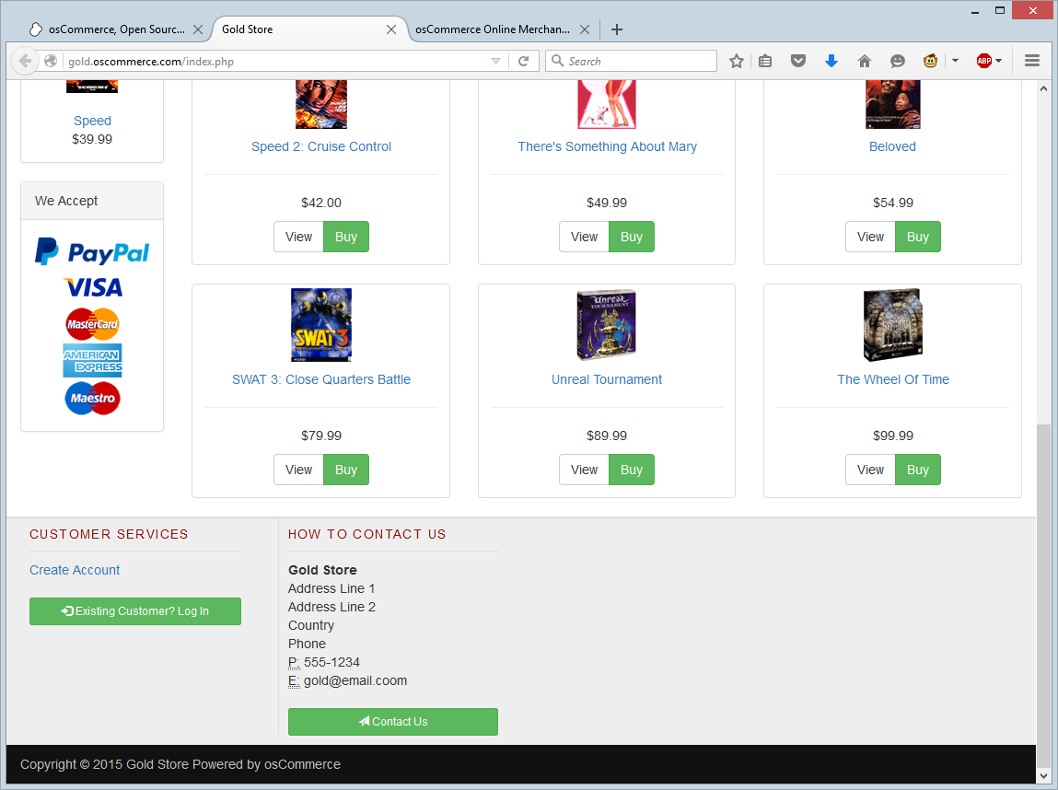

EDGE Install
Navigate to the folder on your webserver when you extracted the files.
You should see this screen if everything is OK.
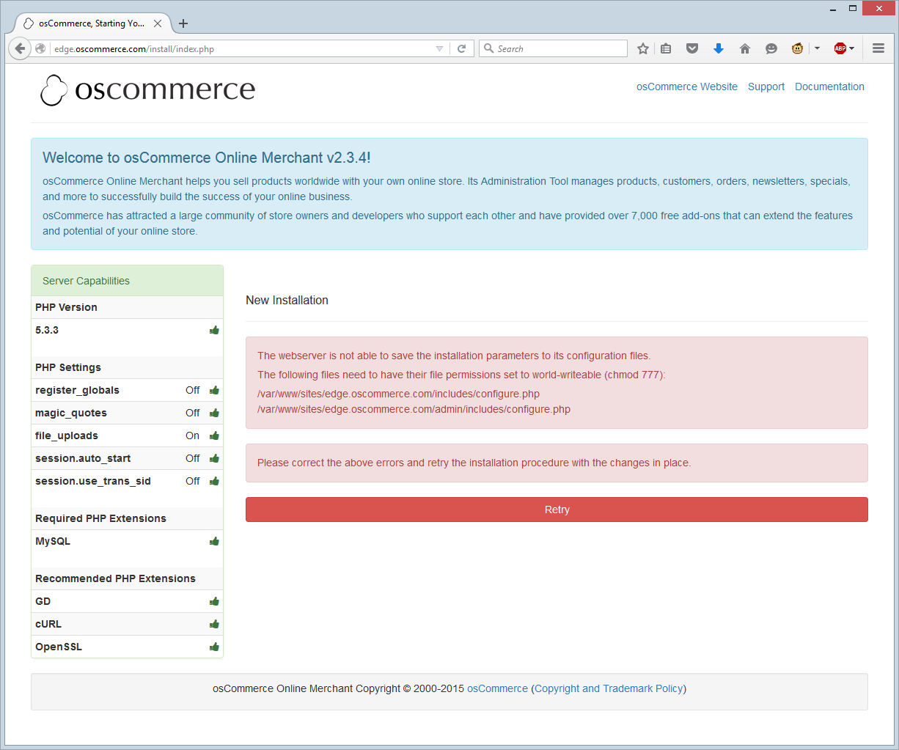

By default the two configuration files are not writable by the web server.
Using either your FTP application or the command line change the permissions on these files to 777.
This is just a temporary measure so the install can update these files with the correct information.

When you have successfully done that, press the “Retry” button and you should see this screen:
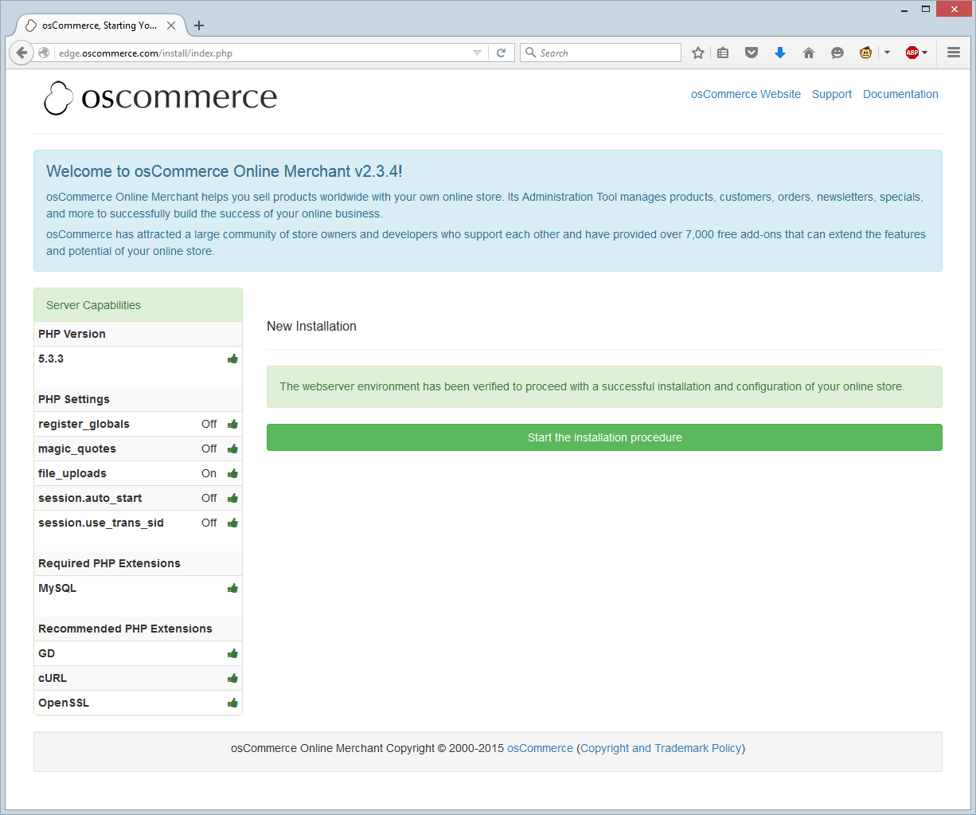
Click “Start the installation procedure” button to continue.

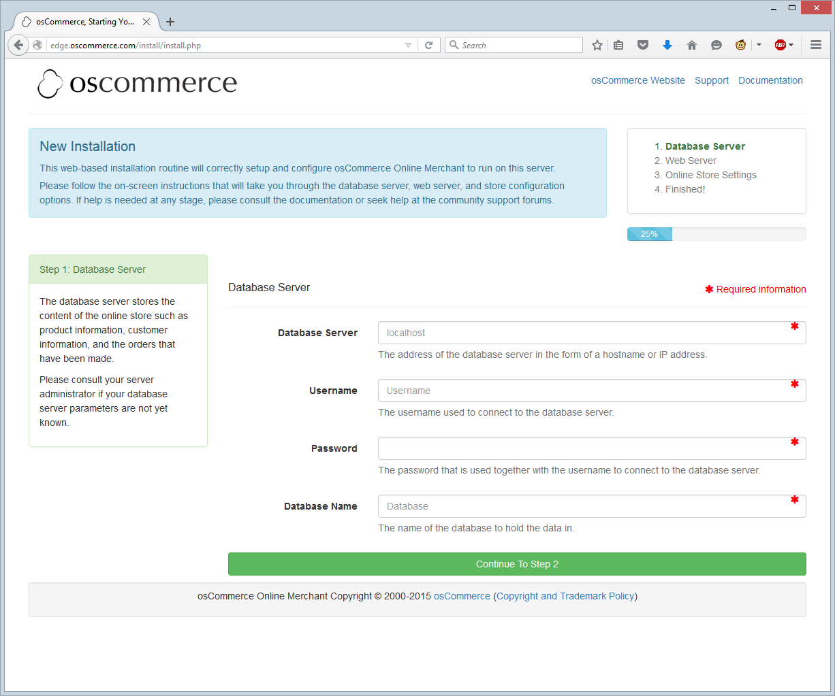
Enter the requested information about the database server and press “Continue to Step 2”
Even if you are using “localhost” as your database server, it still needs to be typed in.

This brings up information on the web server. If you need to, change the information here and press “Continue To Step 3”.
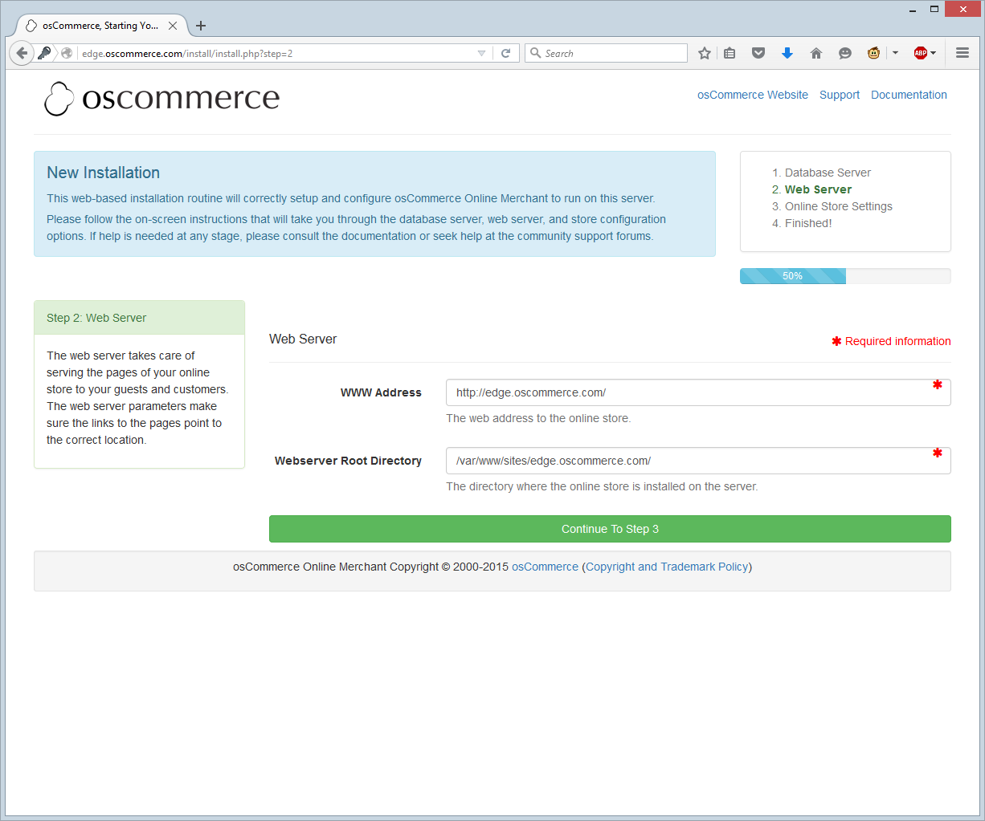

Step 3 brings up a screen asking for basic information about the store. All this can be changed later so don’t worry if you get something wrong.
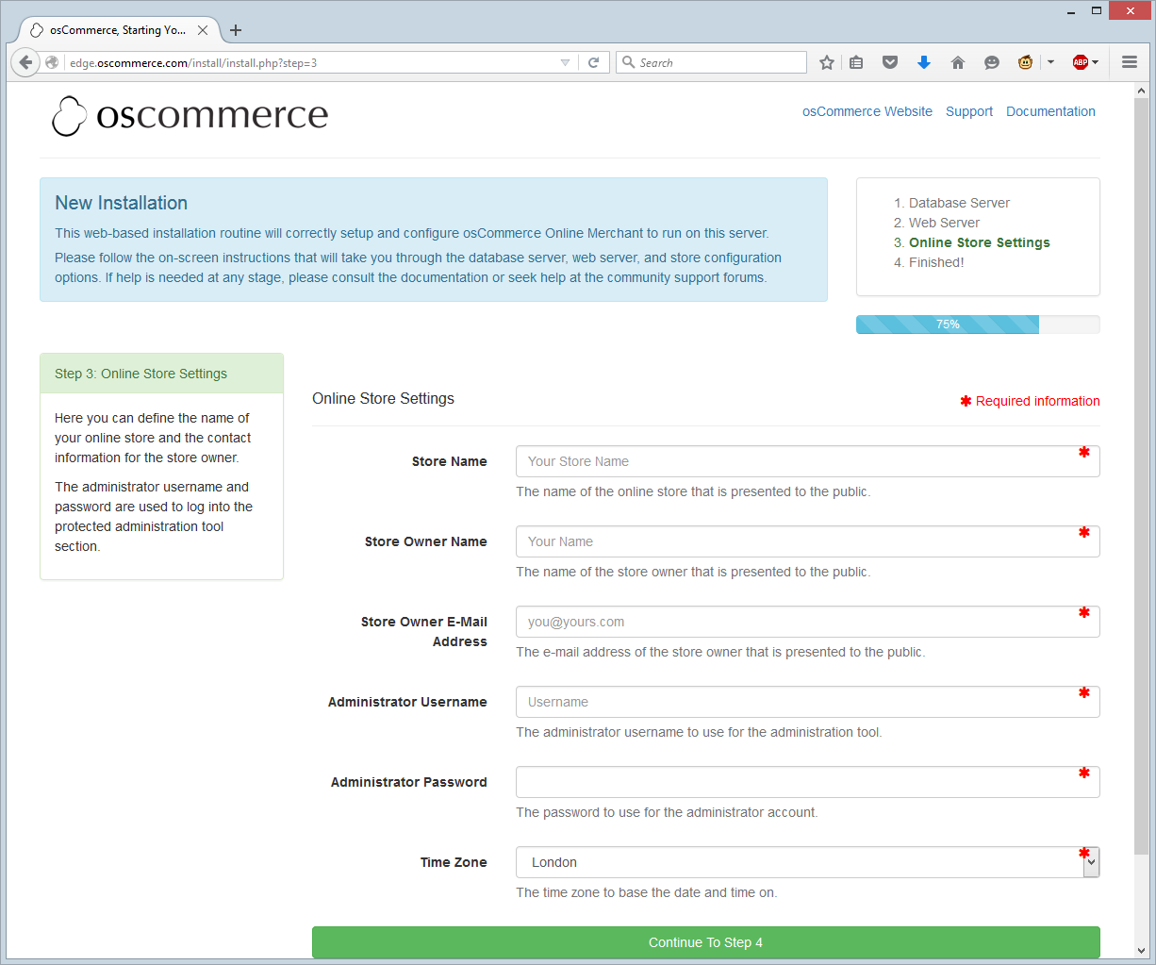

Press “Continue To Step 4” and you should be done.
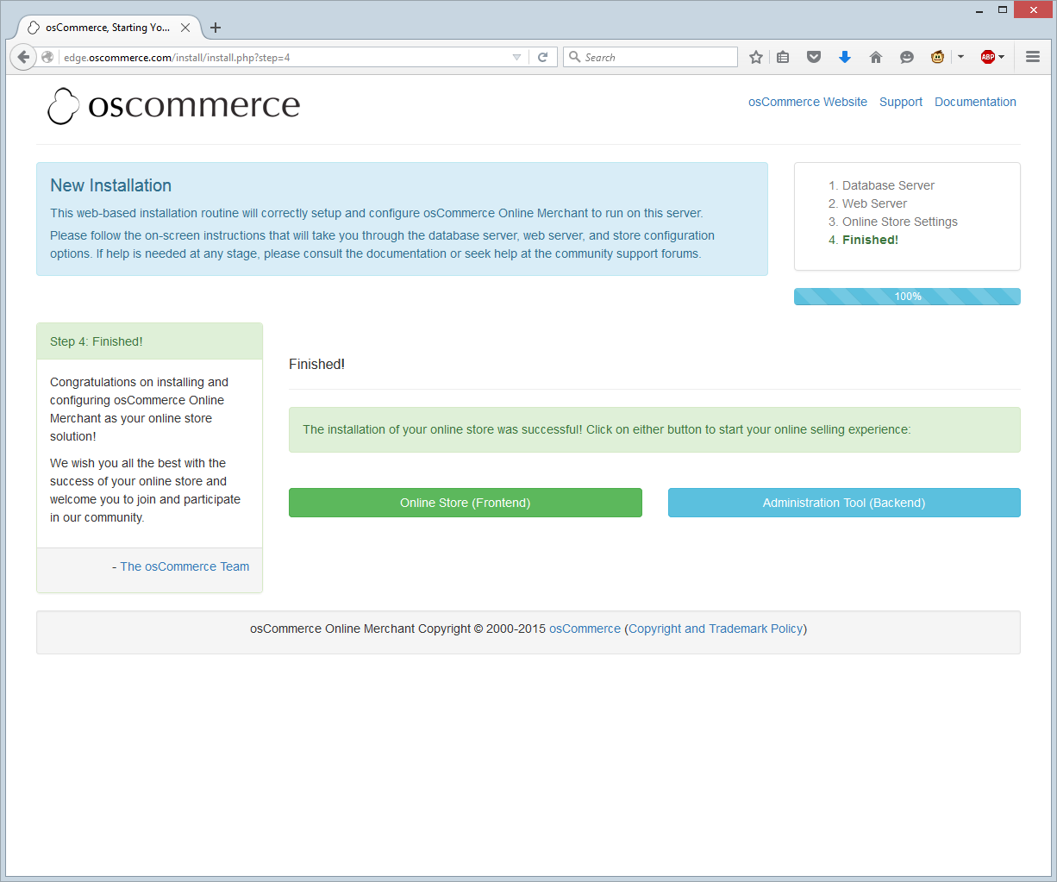
Further steps, currently not mentioned on this screen:
- Delete the /var/www/sites/gold.oscommerce.com/install directory.

- Rename the Administration Tool directory located at /var/www/sites/edge.oscommerce.com/admin.

- Set the permissions on /var/www/sites/edge.oscommerce.com/includes/configure.php to 644 (or 444 if this file is still writable).

- Set the permissions on /var/www/sites/edge.oscommerce.com/admin/includes/configure.php to 644 (or 444 if this file is still writable).
- Review the directory permissions on the Administration Tool -> Tools -> Security Directory Permissions page.
- The Administration Tool should be further protected using htaccess/htpasswd and can be set-up within the Configuration -> Administrators page.
These steps are mostly self-explanatory.
Step 1 is telling you to delete the install folder so this install wizard can’t be run again.
Steps 3 and 4 are ensuring that the configuration files are changed to read only so they can’t be hacked.
Steps 5 and 6 are easy enough to do once you are logged in.
Step 2 is a little more involved.
“Rename the Admin directory located at “/var/www/sites/edge.oscommerce.com/admin”
- Change the name of the admin directory using either the command line, or FTP. For this example it has been renamed to “edge_admin”. Please don’t use this for your install though.
- Edit the “/var/www/sites/gold.oscommerce.com/admin/includes/configure.php” file to reflect this change.
  - Line 7 change
define('HTTP_COOKIE_PATH', '/admin');
to
define('HTTP_COOKIE_PATH', '/edge_admin');
  - Line 8 change
define('HTTPS_COOKIE_PATH', '/admin');
to
define('HTTPS_COOKIE_PATH', '/edge_admin');
  - Line 13 change
define('DIR_WS_ADMIN', '/admin/');
to
define('DIR_WS_ADMIN', '/edge_admin/');
  - Line 14 change
define('DIR_WS_HTTPS_ADMIN', '/admin/');
to
define('DIR_WS_HTTPS_ADMIN', '/edge_admin/');
  - Line 15 change
define('DIR_FS_ADMIN', '/var/www/sites/gold.oscommerce.com/admin/');
to
define('DIR_FS_ADMIN', '/var/www/sites/gold.oscommerce.com/edge_admin/');

Save the file and then go to your new admin folder and log in.
For this example, http://edge.oscommerce.com/edge_admin/

Extra steps required.

When you first go to your store’s front page, you may notice that there is no header or footer visible
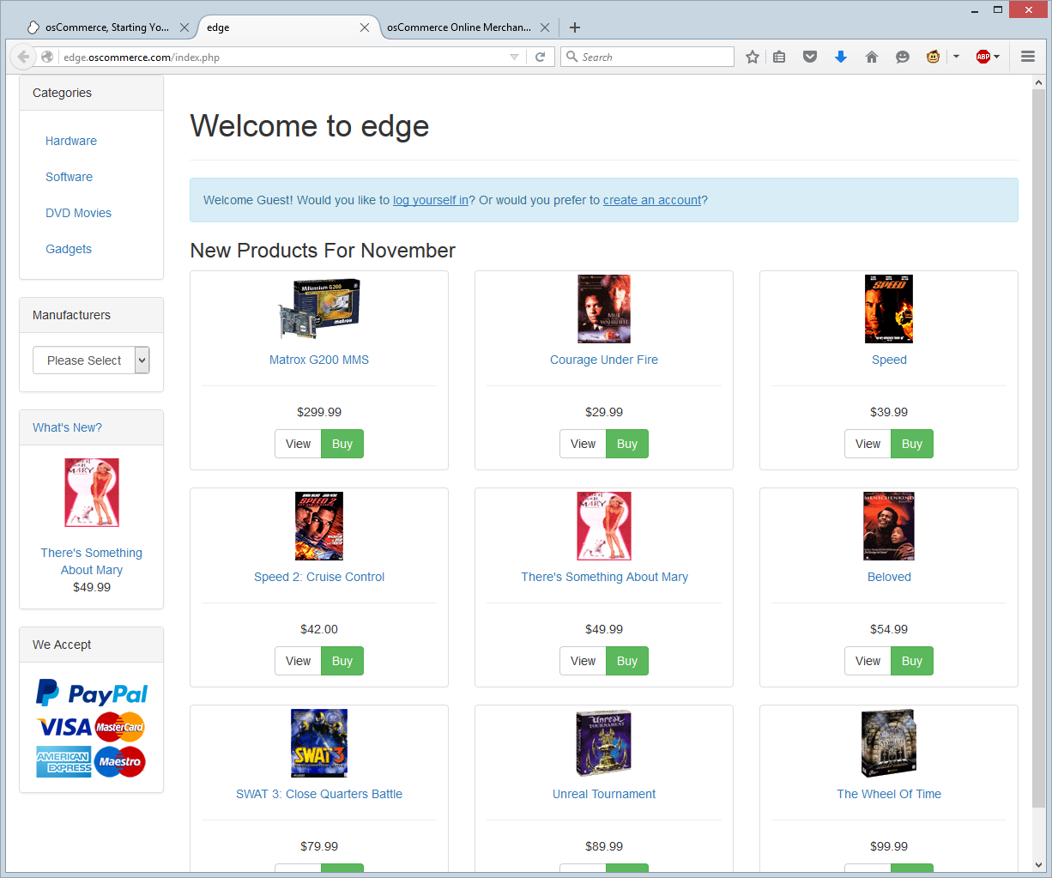
This is due to the bootstrap / responsive layout.
To get them showing follow these steps:
- Login to the admin section of your store
- In the left hand menu, open up the “Modules” box.
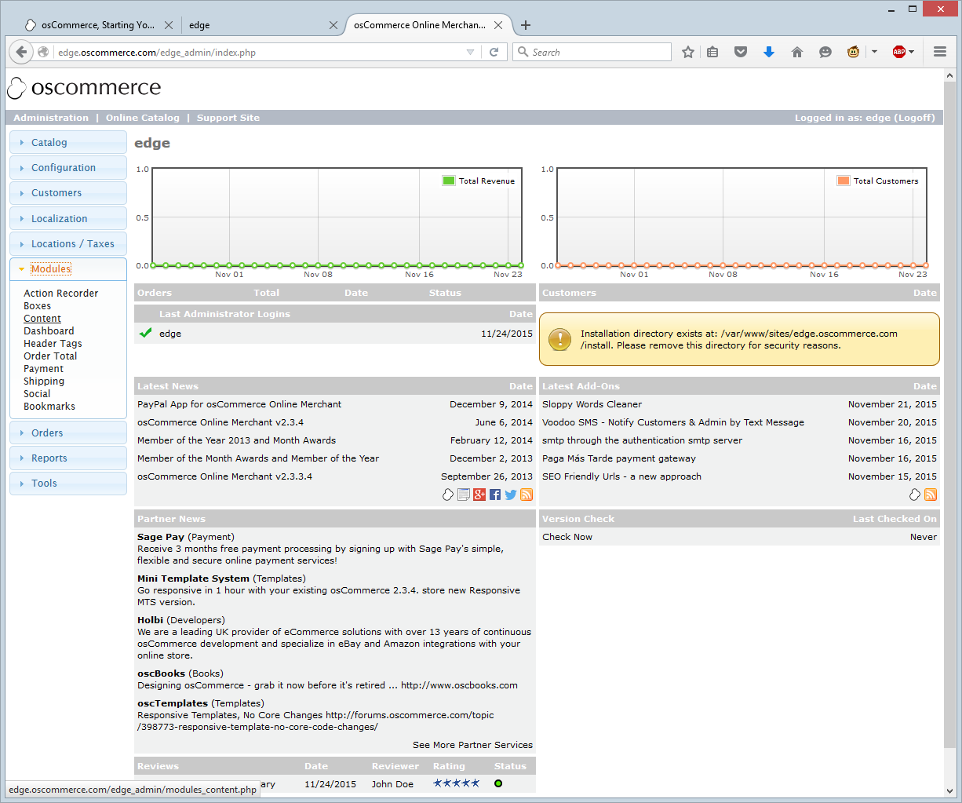

Click content, and then on the top right, click “ + Install Module”
- You should now see a selection of extra modules that can be loaded, such as logo, breadcrumb, and so on. Select the ones you want and click “Install Module”
This screen grab shows a default store with “Breadcrumb”, “Logo”, “Search Box” and “Navigation” switch on.

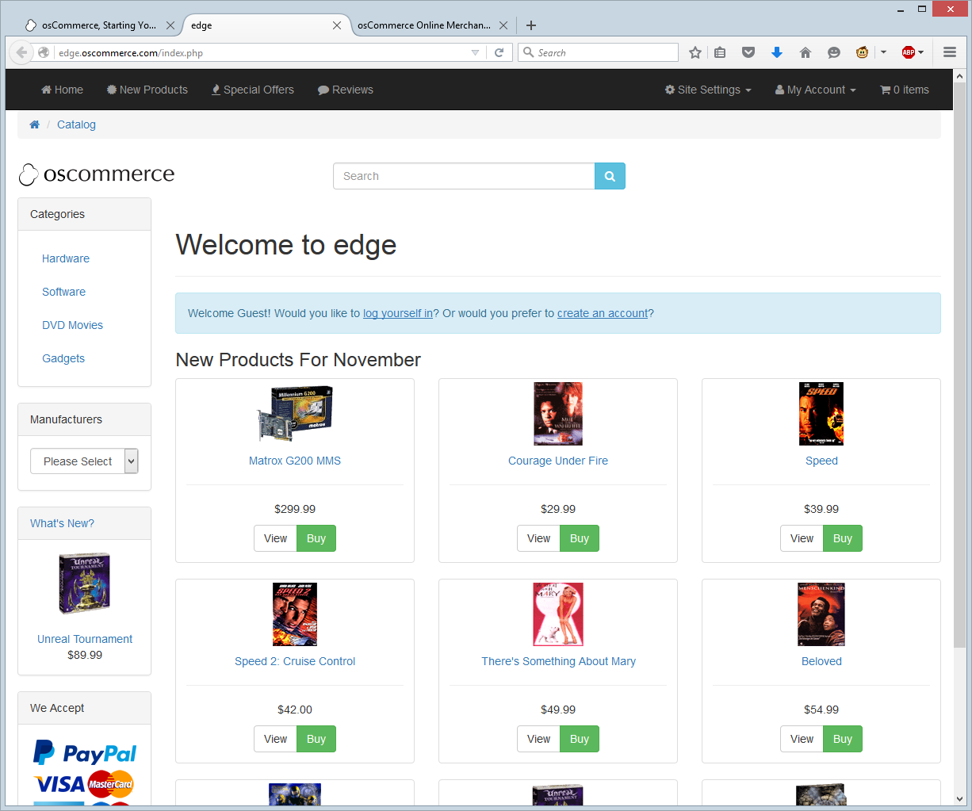

The same is true for the footer.
By default it looks like this:
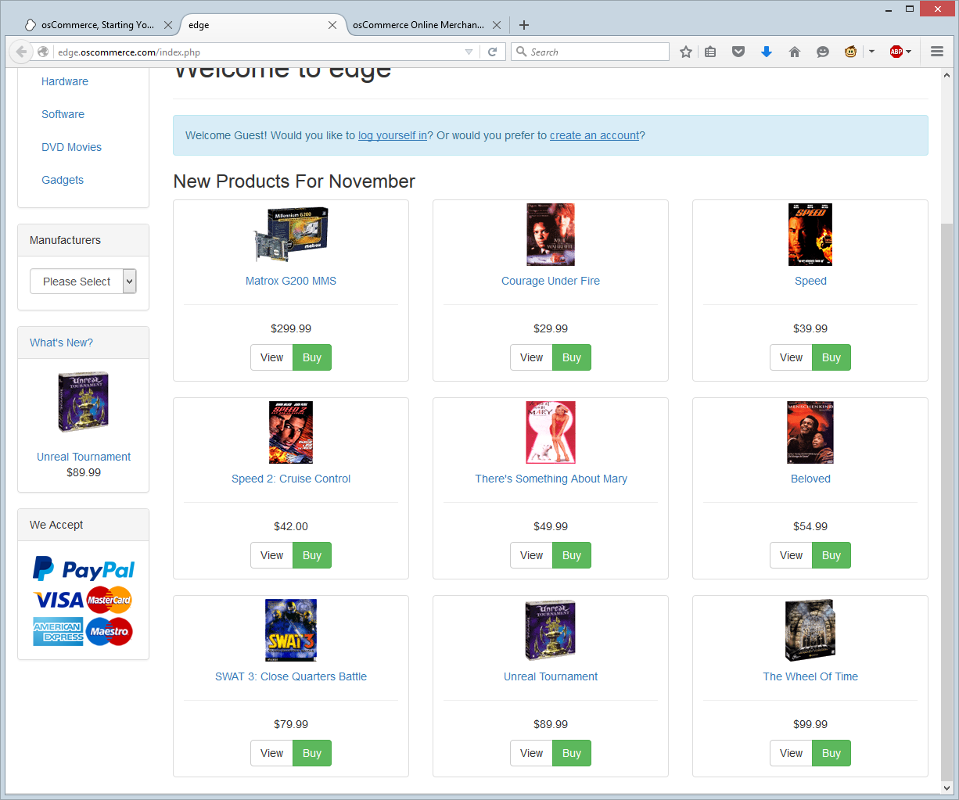
But with “Account block”, “Contact Us Details” and “Copyright Details” on, it looks like this.


